Analysis and Research

Introduction

My idea for this project is a simple game, with features added to it which are complex to code. The premise of the game is that you are controlling a climber, who is climbing up a rock face, trying to get as high as possible before he falls. There will be options to jump, move left and right, grab a hold and dodge (these will all be keyboard buttons). The climber can fall by not reaching the next hold and falling, or from not dodging a falling boulder. If the climber falls, an animation will show them how they fell, their score and their high score.

When the game is first opened, it will take the player to a home screen. The home screen will include four buttons: a play button, one to look at the leaderboard, one to customise the climber, and a settings button.

The way the game works is based off rules (e.g. climber can't touch spikes), interactions (e.g. jumping) and calculations (e.g. score). This means that computer logic can easily model this using if statements for the rules (e.g. if hand is touching spike), inputs for the interactions/controls, and basic functions for the calculations (e.g. score += 1).

I have a lot of ideas about ways to make the game challenging for the player, and also for me to code. Some of these ideas include: Falling boulders which you have to press a button to dodge, Enemies which you have to defeat, two player mode with powerups, difficulty settings, different holds which do different things (for example one which disintegrates one second after you grab it or one which moves), a leaderboard with everyone who has ever played and their score (for this you’d have to enter a username at the start). All of these ideas will be addressed after my research on other games and surveys.

My inspiration for this game was a mobile and arcade game called ‘Doodle Jump’. I used to play Doodle Jump a lot as a child but always thought there were things that could be added to it to make it better. These were things like the option to change your character, difficulty settings, and two player mode. I also wanted to give the game a personal twist, and I really enjoy indoor and outdoor climbing, so I thought it would be a perfect fit for my game to be about a climber.

I’m naming my project “The Eternal Dyno”. I think it makes the game seem very grand and also sums the game up, as a ‘Dyno’ means a dynamic climbing move, and the aim of the game is to do this for as long as you can – hence the word ‘Eternal’. Also, from hearing the name of the game, a child’s parents would be able to understand it and be reassured that the game their child is playing is appropriate and adventurous.

Research

My first piece of research is on the game ‘Doodle Jump’ as this is what I based my idea around, so I think it will have lots of features which I could implement into my project.

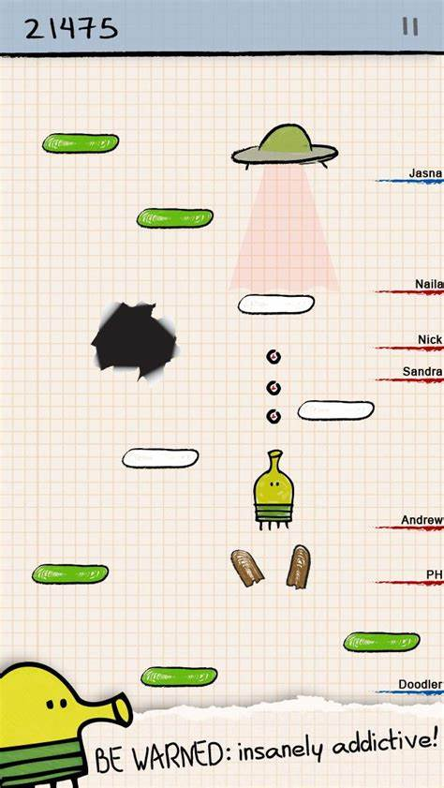

Figure 1 - Doodle Jump in-game, image from google play, [Doodle Jump – Apps on Google Play](https://play.google.com/store/apps/details?id=com.lima.doodlejump&pli=1)

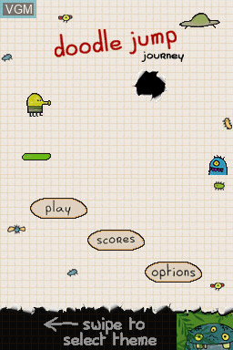

Figure 2 - Doodle jump main menu, image from videogames museum website, [Doodle Jump Journey for Nintendo DS - The Video Games Museum](https://www.video-games-museum.com/en/game/Doodle-Jump-Journey/81/5/42255)

|  |  |
| --- | --- |
| **Features I plan on implementing:** | **Features I won’t be implementing:** |
| A great feature in this game is that there are different types of platforms you can land on. I think this makes the game a lot more fun and challenging for good players, and I’m planning to add different climbing holds which do different things. | Something I won’t be implementing is the fact that the character is constantly jumping. I think its better for the player to manually move and make the character jump, as it adds more of a sense of control to the game. |
| I like how the current score is always at the top, as it lets the player know how they’re doing at all times, meaning they can push for a high score (having known what their high score was already). | I don’t like the design of the main menu and how the background is an image of the actual game. It makes it confusing for older people who don’t usually play these games, and young children. I think its better to have a clear difference between the menu and the actual game as its simpler and easier to understand. |
| I like the idea of different themes (as you can see from the bottom of the second figure, you can swipe to change themes). I think it makes the game more interesting, being able to really customise the game to how you like. | I don’t like the simplistic art style of doodle jump. It’s very minimal and boring to the player. It may cause them to not play the game for as long, so I’m going for a scenic visual style. |
| The scores option is a great way to add fun competition to the game. It motivates them to beat their friends or beat the people ahead of them in the leaderboard. This makes it more fun for all players, especially ones who have friends that play. | There is only one game mode with doodle jump. This is very limiting to players and makes the game too repetitive, so I think having multiple game modes would really increase the replayability. |
| Things I may add:  Enemies – Adds a good challenge to the game and makes it more interesting. |  |

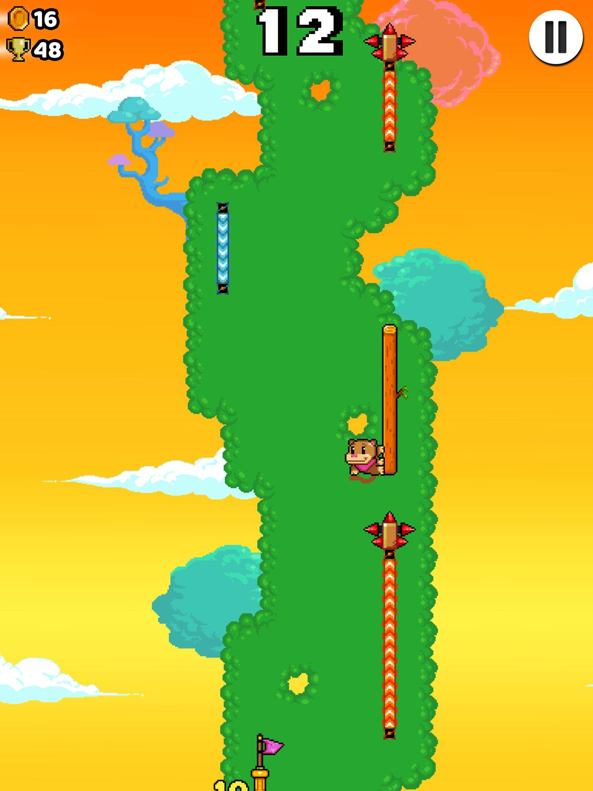

Figure 3 - Wall Kickers in-game, image from pocket gamer, [Wall Kickers cheats and tips - How to get the monkey really high | Pocket Gamer](https://www.pocketgamer.com/wall-kickers/wall-kickers-cheats-and-tips-how-to-get-the-monkey-really-high/?page=2)

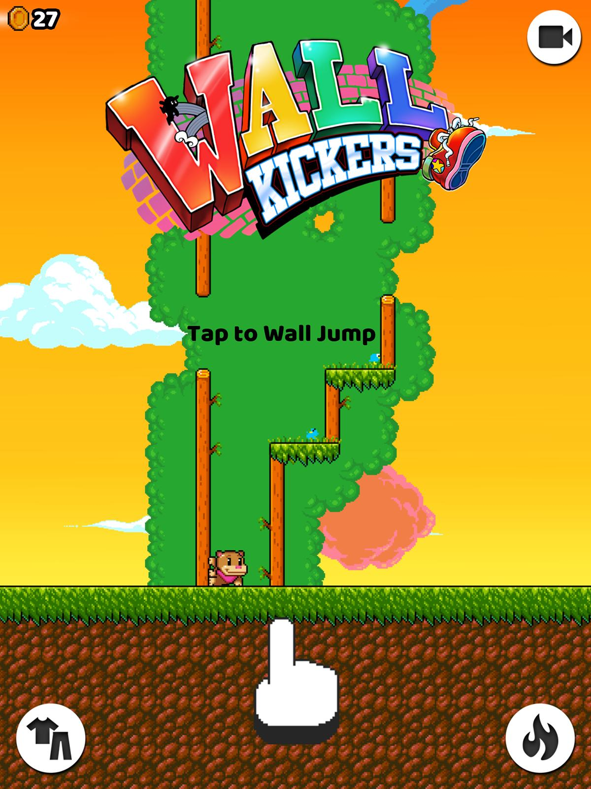

Figure 4 - Wall kickers main menu, image from pocket gamer, [Wall Kickers cheats and tips - How to get the monkey really high](https://www.pocketgamer.com/wall-kickers/wall-kickers-cheats-and-tips-how-to-get-the-monkey-really-high/)

|  |  |
| --- | --- |
| **Features I plan on implementing:** | **Features I won’t be implementing:** |
| I like this colourful, scenic background a lot. I think it makes the game easier to play for longer periods as it looks really nice. It also makes the game more interesting and can lure new players who like how it looks. I’m planning on making my background scenic and good looking for this reason. | Mechanics – a thing I don’t like about this game is how the only control is to tap. Usually simple is good, but I think this is too simple and not challenging enough, especially as my game will be played on keyboard and mouse and is meant to be challenging for the player. |
| Checkpoints (bottom of figure 3) – I think checkpoints are a great way of making the game less intense and more chilled out, without making the game itself any less challenging. This is good because the purpose of my game is to be challenging, but not too stressful. | This is not shown in the image, but the majority of coins collected are from random drops while not playing the game, this decreases motivation to collect the coins while actually in game, something I think is important, so I wont be including these random drops. |
| Coins – Being able to collect coins which you can later spend is good as it adds more engagement to the game, and a reason to keep playing |  |
| High score in the corner – having a high score in the corner while playing is a good way of motivating the player to push further and focus more because it gives them a goal. This makes it more fun for all players. |  |
| Outfit customisation – this makes the game more personalised to each player and keeps players engaged due to the individuality of their character. It also can make them want to play more, and get more coins to unlock new characters. |  |

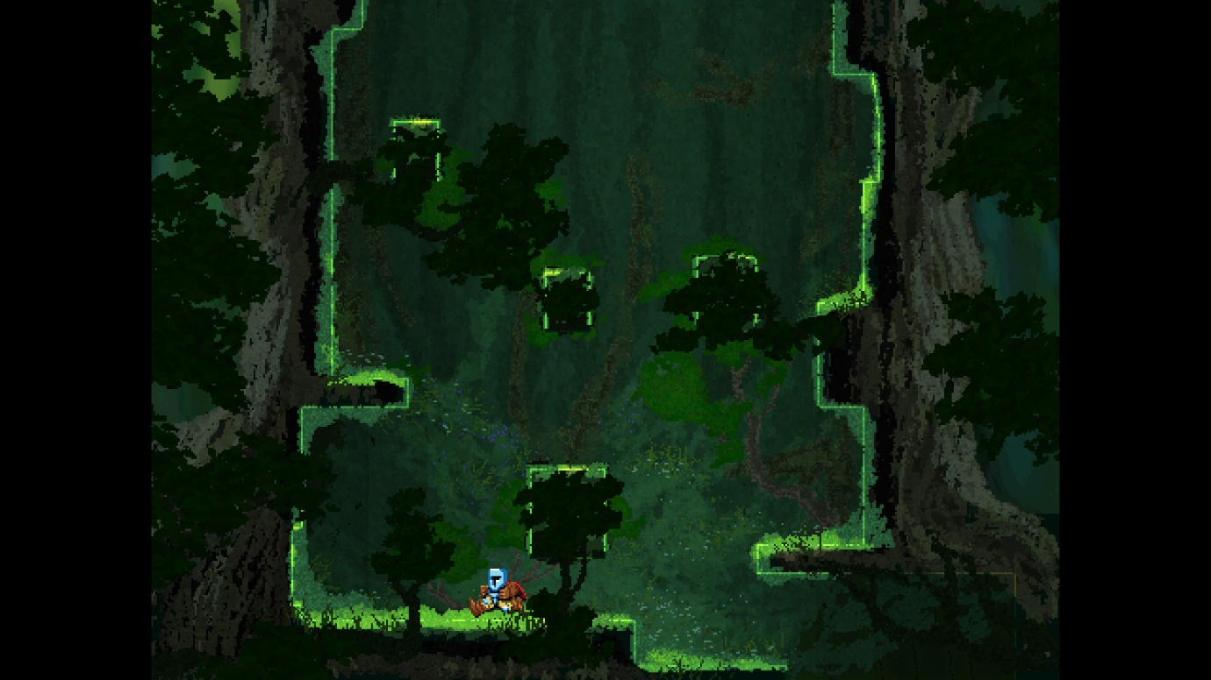

Figure 5 - Jump King – In forest, image from jumpking.com, [Jump King - There is a Smoking Hot Babe at The Top!](https://www.jump-king.com/)

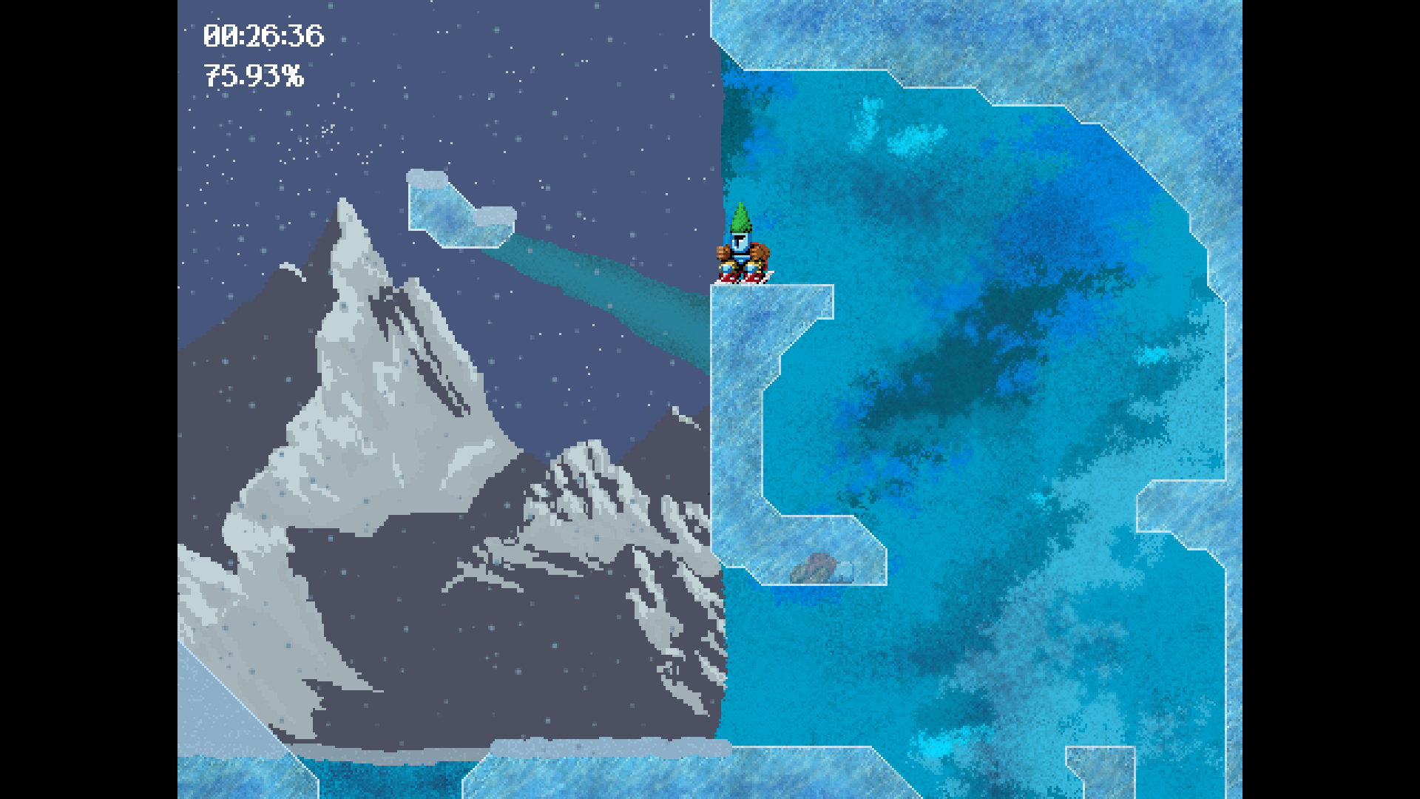

Figure 6 - Jump King - Ice level, image from jump king plus, [Back to the Babe! – JumpKingPlus – An enhanced version of Jump King. ✨](https://jumpkingplus.github.io/workshop/13/)

|  |  |
| --- | --- |
| **Features I plan on implementing** | **Features I wont be implementing** |
| Mechanics – I like how the mechanics are simple, left right and jump. I think it makes the game quick for a player to learn, which is good as its not meant to be challenging to control, just challenging to play. Although I like the simplicity of these controls, I will be adding a few more simple ones to add variety to the game. | Falling down takes you back to the start (no restarting). Even though this is very similar to resetting after each fall, I think having no animation or display to show that you are restarting makes the game more infuriating (as if you’ve spent 30 minutes on the same try, instead of having 10 tries). |
| Different themes – I like that each level in Jump King has a different theme, one in a forest, one with ice which is slippery. This makes the game so much more interesting and a lot less monotonous for players (just one simple theme which stays throughout the whole game). Playing with different themes will always be fun and engaging for players. | Levels – I don’t think having levels fits my game, as its meant to be an infinite game. |
|  | Timer – adds too much stress and I don’t think it works with my game. |

Stakeholders:

‘The Eternal Dyno’ is primarily aimed at children aged 7 – 10 who have access to a computer. This is because these children will likely enjoy games which are easy to understand (but have some competitive and challenging features), and have a really appealing, colourful style. I’m designing this game with these players in mind by giving it simple controls, a visually pleasing style, and a gradual increase in difficulty as the game goes on so its not too overwhelming for them.

Children aged 7-10 will find it hard to get access to the game if it costed money (Either wouldn’t want to spend money on it or would be a hassle to get their parents to buy it), so I’m making the game free. This means as long as they have a computer, anyone can access this game, no matter their financial situation. I think this is important as it creates a welcoming sense about the game, and will attract a whole variety of players. It also means the game is quick to access as there is no parental permission needed, meaning children can play it anytime they want.

I think this game would really fit my stakeholders’ needs, as it gives them entertainment and relaxation. I think playing it would be a nice way to wind down after school, or just stay occupied in their free time. My game also provides them with a fun, social and competitive aspect by having a leaderboard. This means they can see their friends scores, which gives them a goal to beat and something to talk about at school, which could even help them make friends. Additionally, the game is about climbing meaning it could potentially inspire them to start climbing or just view sports with a positive mindset from a young age, which is a really unique benefit to my game.

Teachers would also be minor stakeholders in my game. They could allow children to play ‘The Eternal Dyno’ in their breaks or as a fun way to reward their class for doing something.

Requirements:

To tailor my game requirements to my stakeholders, I sent out a Microsoft Forms questionnaire about my game to my younger sister, and she sent it to her friends (All of which are stakeholders). The questionnaire had 9 questions and I gathered 10 responses overall, which I will use to decide on the main features of ‘The Eternal Dyno’

These are the 9 questions asked:

1. Do you prefer playing games on a desktop or on mobile?
2. Do you like endless games? (Games where you try and get a high score)
3. Do you prefer games which are quick and easy to play or games that are challenging?
4. Which of these features do you think is better for my game? These will be for an endless climbing game where you try to get as high up as possible before falling
5. How much do you like customisation of a character in games on a scale from 1-10?
6. How important do you think a leaderboard will be for my game?
7. Do you think having powerups (like low gravity or increased strength) would make this game more fun?
8. Do you think one player mode or two player mode is better for this game?
9. Do you think having difficulty settings would make this game more fun?

These are the responses:

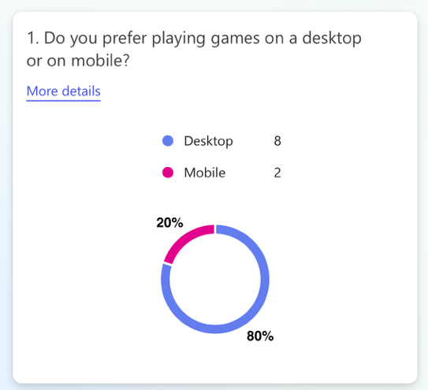

I added this question to make sure my stakeholders wanted this game to be a desktop game, and they did, so I wont need to make it a mobile game.

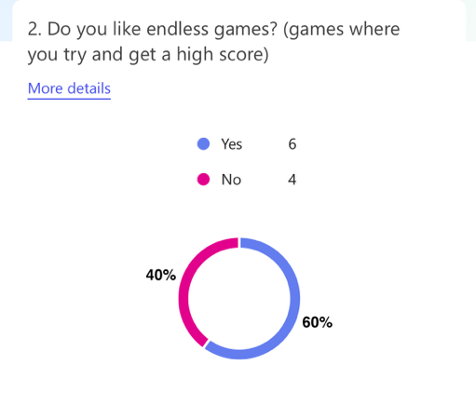

This was another question just to double check I had the right idea of what kind of game my stakeholders would like, and it was a success, as 60% of them liked endless games

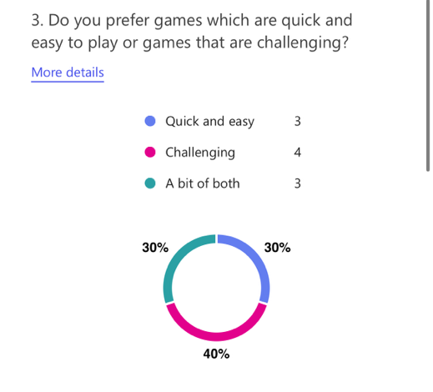

This was an important question as it let me know the mix of my stakeholders who like challenging games vs the ones who like them to be easier. It turns out that there is a fairly even split. This leads me to the conclusion of making the game have easy controls and be easy to start with, but get challenging as the game goes on. I’m also considering adding difficulty levels

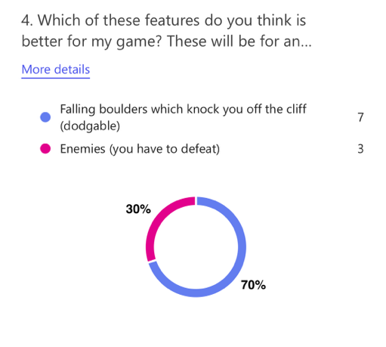

Most people (70%) preferred the idea of falling boulders over enemies which you have to defeat. This leads me to the conclusion that its essential to add falling boulders which you can dodge, and not so important to add enemies.

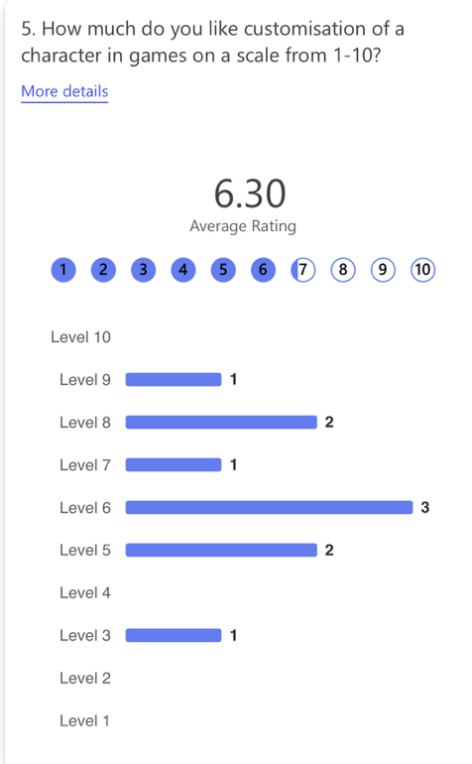

Character customisation generated mixed opinions, ranging from 3/10 importance to 9/10 importance. The average, however, was 6.3 which leads me to the assumption that most of my stakeholders would like character customisation in my game. I think the overall importance of this feature is “Desirable”.

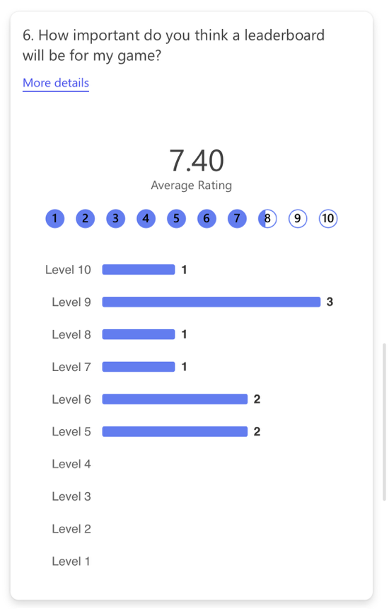

There wasn’t a single rating for a leaderboard lower than 5, and the average rating of importance was 7.4. This brings me to the conclusion that a leaderboard is essential for my game.

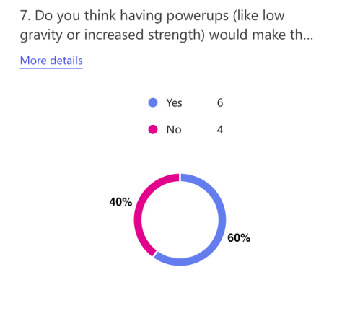

60% of my stakeholders said that powerups would make the game more interesting, however I think 60% is not enough, as then 40% of stakeholders wouldn’t necessarily play it and to code this would use up a lot of valuable time which I could spend on things that are more desirable to my stakeholders.

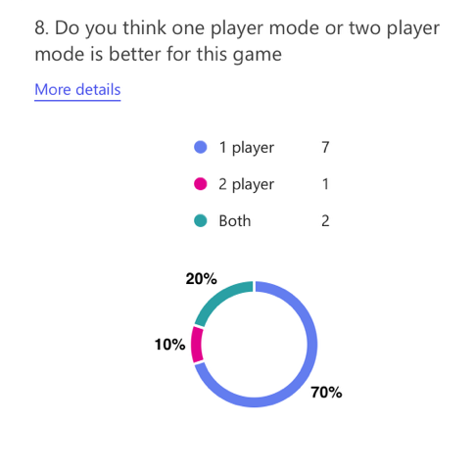

70% of people who answered this questionnaire would prefer the game to be one player, therefore I’m noting that it is essential that this game be a one player game.

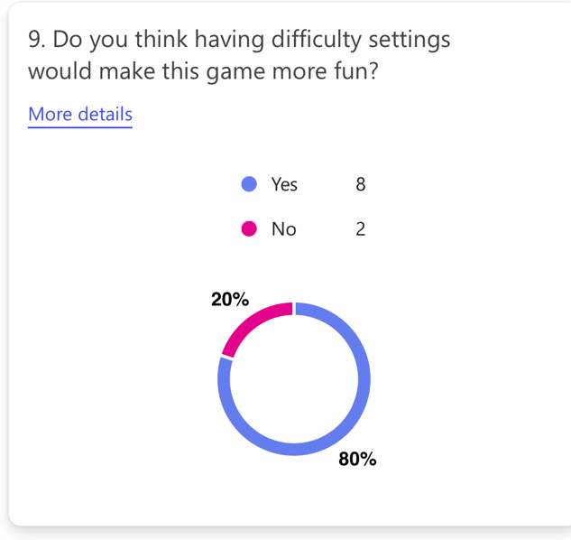

Almost all of the stakeholders who answered the questionnaire think the game would be more fun with difficulty settings. This is helpful because now I can confidently say that adding difficulty settings is essential and will be worth coding as more players will find it fun.

Feature Table:

|  |  |  |  |  |
| --- | --- | --- | --- | --- |
| General feature | Specific feature | Explanation | Justification | Importance |
| Main Menu Screen | Background | A background image of a picturesque cliff | Every game has a background whether simple or detailed, as it creates a depth to the game, giving it a nicer feeling to play. I’m making sure mine is beautiful and picturesque because it brings the player straight into the climbing theme and appeal to them visual (meaning the game is likely to appeal to them too). | Essential |
|  | Background animation | A climber climbing up the cliff | I want to add this because something moving will capture the players attention, engaging them and making the game feel active and lively. | Desirable |
|  | Play button | When clicked, you’ll start the game | I’m using a play button as it eases the player into the game, they can press it whenever they want instead of being put straight into the game and potentially getting overwhelmed. | Essential |
|  | Settings | A screen which lets you change the volume of sound effects and music (if added) | I want to add a settings option into my game because it means the player can personalise and have control over their experience, meaning it can cater to their needs (maybe they're listening to other music while playing so turn music off but keep sound effects on). | Important |
|  | Leaderboard (username input) | A leaderboard which shows the top 25 scores ever reached, with each persons username | I think a leaderboard will add so much more engagement to the game, as it adds a competitive aspect meaning people will want to beat their own or their friends high score, so play it more often and for longer periods. It also makes the game more fun as you can play for a bigger goal, not just to beat your high score but to be the best player. | Essential |
|  | Character customisation | A screen which allows you to add (for coins) cosmetics to your climber, like a backpack or a different t shirt | Adding cosmetics to the climber means players can express their personality while playing. Also, because buying a cosmetic costs coins, it motivates players to play more in order to unlock better cosmetics, meaning better long term engagement to the game from the players. | Desirable |
|  | Help button | A simple screen which displays each control and what it does | Giving new players clear instructions is important as it means they’ll be less likely to be overwhelmed by the game when they start. Making it a button means they aren't forced to look at the controls if they want a challenge (alot of my stakeholders want the game to be challenging). | Essential |
|  | Coin count display | Shows how many total coins you have, updates in game | This is good because it gives players a clear goal (to afford a cosmetic they want) and shows how close they are to achieving it at all times. | Essential (If customisation is added) |
| In Game | Controls | Controls for left, right, dyno(jump), grab, and dodge (you cant move while dodging) | Most of these controls are the same as all simple PC games, meaning players playing this (who are likely to have played a computer game before) will instantly understand the controls. The other controls which aren’t in most games (like dodge) will be designed to be as intuitive as possible (e.g. using the d key for dodge). This means players don’t have to spend time learning the controls and get straight into the game, giving them a smoother experience. | Essential |
|  | Height and high score displayed | In the top corner, your current height and high score will be displayed while playing | I think this is good because players can give themselves their own personal goals, like reaching a certain score or beating their high score. This keeps them engaged as they're always trying to improve. | Essential |
|  | Platforms | There will be many different platforms/ledges, the main one being solid rock to jump to. Other examples are: ledge which instantly crumbles, ledge which slowly crumbles, moving ledge, sharp ledge | Having different types of platform adds fun variety and challenge into this game. It means that players have to think strategically in game choosing which platform to climb to and how long they can stay on the platform, adding that difficulty which 70% (40% + 30%) of my stakeholders want. It also means that the game doesn’t get boring, every game will have different platforms in a different order, each one requiring a different strategy to overcome it. This means players will play for longer periods and also keep playing the game on different occasions ensuring long term playability. | Essential |
|  | Enemies | A basic enemy which you have to defeat to keep climbing | Enemies would add excitement and challenge to the game, as they force the player to be ready at all times for changing their strategy to eliminate it without also falling off a platform. | Highly Unlikely |
|  | Falling boulders | A falling boulder once in a while, which hits you if you don’t dodge | A falling boulder, much like an enemy, forces the player to be ready at all times to dodge it, but its also realistic, as when climbing a cliff, falling rock is a real threat. I think this realism will not only make the game more fun and difficult, but it will also alert players of the unexpected dangers when cliff climbing. | Essential |
|  | Changing Background | As you reach certain heights, the background will change (e.g. from sky to space) | A changing background gives the user an insight to how far up they've climbed (e.g. background changes from forest to sky), giving them a sense of accomplishment and another way to measure how high they can climb in this game. Not only does it do this, but its also aesthetically pleasing and adds variation to the background. | Unlikely  (Still background is essential) |
|  | Ropes to grab | Sometimes there may be a rope where you can grab it and climb up | Ropes are a good addition to my game, because it adds a new mechanic, instead of always jumping. This switches up the play and makes the game less repetitive meaning players are less likely to get bored of it. | Desirable |
|  | Coins | While playing, there will be coins to collect, which you can spend to customise your character | Coins are a great incentive for players to keep on playing, as players will want to collect coins to change the way their climber looks. There will be increasingly priced cosmetics, meaning players will have to collect more coins to get cosmetics that look cooler meaning they have to play the game for a longer period. | Essential (if customisation is added) |
|  | Pause button | There will be an option to pause your game in the corner of the screen at all times | A pause button in this game makes it more convenient for players. If they are doing well but have an urgent task, they can simply pause and play when ready and they wont lose their progress. This is good because it means players don't have to dedicate time to play this, they can play it in bursts and still do well, great for players who like multitasking. | Desirable |
|  | Fall screen | When your character falls, a screen will show which displays a message, and how far you climbed, and if you got a new high score | A fall screen is good as it provides clear feedback on how you did that game, how you fell and what you score was. This is a lot better than instantly restarting the game, as then the player wouldn't know what their score was that game. | Essential |
|  | New high score (mid game) | When you reach a new high score in the middle of the game, a little animation shows up in the corner to show you | This will encourage players mid game to get a high score. It will also give the players a sense of achievement when they do beat their high score, motivating them to play another game to beat it again. I can do this easily by constantly comparing the current score to the high score, making this feature very quick to code and with a lot of benefits. | Desirable |
|  | Powerups | Little benefits like low gravity, or strength | Powerups would add even more variety and strategy to the game, as players need to decide how to use them to stay alive or get a high score. It would give a different outcome and feeling to each game, meaning players are less likely to get bored. | Not important |
|  | Fall animations | Animations depending on how you fall, e.g. if you don’t touch a hold, it will show a hand reaching out for nothing | Falling animations would really enhance the visual feel of this game, making it feel more real too. I think it would also remove some frustration from a loss, as it would be entertaining to see the animation. | Important |
| Miscellaneous | Two player mode | A splitscreen mode where there are two players, each trying to get the highest score | This would make the game a lot more sociable and competitive, encouraging people to play with friends or family. This makes players more likely to replay my game, as they can share the experience with other people. | Not important |
|  | Difficulty settings | Settings which allow you to change how hard the game is | Difficulty setting would allow my game to appeal to anyone, no matter if they like to play easy or challenging games. Also, 80% of my stakeholders think this would be a good addition. My idea is that new players could start on low difficulty and work their way up gradually as they improve. | Essential |
|  | Sound effects | Different sounds depending on what the climber is doing | Sound effects would create an immersive and more satisfying playing experience. It makes the game feel smooth and responsive in my opinion. I think they’d be fairly easy to implement as each sound can be triggered by an event, such as jumping. | Desirable |

Limitations

Not enough time to implement all the features – There are countless features which I could add to this game to make it more fun, challenging and sociable, however due to the fact that I have limited time and am developing the whole game on my own, I wont be able to include some of them. This is why above I have listed the priority of each one so I can focus on getting the ones most wanted by my stakeholders first, and then maybe include some extra ones which make the game better (E.g. I’m focusing on implementing falling boulders rather than enemies, then if I have time at the end I’ll add enemies, as 70% of responses to my survey preferred falling boulders).

Basic 2D graphics – Another limitation of this game may be the basic 2D graphics. Although the game may run functionally and smoothly, the graphics may feel to simple for the user (similar to how doodle jumps graphics felt to me). This could make the game feel less appealing to players, who might be more used to faster paced, dynamic graphics. To combat this, I’m making sure my graphics are vibrant and good-looking, to engage the all users and overshadow the fact that the graphics are simple.

Not on mobile – Although 80% of my stakeholders prefer playing games on desktop, there are obviously some who won’t have a desktop but do have access to a mobile phone. Unfortunately, my game controls aren’t optimised for mobile playing, as it utilises a keyboard and mouse for controls. This means it will be very hard for me to make my game work on mobile devices as well as desktop, which limits my player base to only people who have a computer.

Hardware and software needed (for development and playing)

Hardware:

Computer or laptop

Keyboard and mouse/touchpad

Software:

IntelliJ – to code my game on

Java Swing – To implement graphics to my game

Up to date software - In order to run the game

Computational methods

Decomposition – I’m breaking down this whole game into small, simple steps. Firstly, each feature will have its own class, for example ‘Character’. Then I’m going to break this class down into each feature that it needs, for example ‘movement’ and ‘skin’. I’m doing this because it will make coding the game a lot simpler than just doing everything at once, and having many clear small targets makes it easier to fulfil the requirements for the game.

Abstraction – I will be using abstraction in many ways while developing my game. Firstly, before even starting to code my game, I’ve picked out the features that are the most important and I’m focusing on these, for example I’m not focusing on making my climber/character fully realistic, its going to be a sprite with a few different looks. This is because making it fully realistic would be overly complicated to code and isn’t necessary for my game.

Pattern recognition – To develop the game more efficiently, I’ll be using pattern recognition (identifying similar elements in my game and repeating them). An example of this would be realising that each different platform/ledge in my game would react similarly to collision, no matter what platform/ledge type it is, the player will always grab it to start with. Using this pattern recognition means I can reuse the same function for this with all different platforms. This significantly reduces the amount of time I spend coding and also makes the code more efficient and easier to read. Overall, I think this computational method will be very useful to me so I will definitely use it to my advantage.

Success Criteria

For me to deem my project as a success, these are the measurable criteria that I need to meet as a minimum.

1. Meets **all** essential requirements

Essential requirements:

Background screen, play button, leaderboard, help button, controls using arrow and letter keys, height and high score displayed, different platforms, falling boulders, still in-game background, fall screen, difficulty settings.

Essential requirements IF customisation is added:

Coins to collect, coin count display

I can measure this by going through each requirement after the game and ticking off the ones that are met.

1. Pleases majority of stakeholders for at least 6 of the 8 questions asked in my survey (not including question 1). Below are what the majority of respondents answered for the 8 questions of my survey:

(These ones are essential already so ignore)

* Game has difficulty settings
* Game has Falling boulders
* Game has leaderboard
* Game is endless
* Game is challenging
* Game has character customisation
* Game has Powerups
* Game is single player

I can measure this after coding my game by checking that at least 6 of these 8 bullet points apply to it. To measure if the game is ‘challenging’, I will get as many of my stakeholders to play the game and send them an email asking them to rate how challenging the game was on the hardest difficulty out of 10. If the average answer is above 7/10, I will count this as being difficult.

Design

My GUI Design (zoom in for justification)

Main Menu

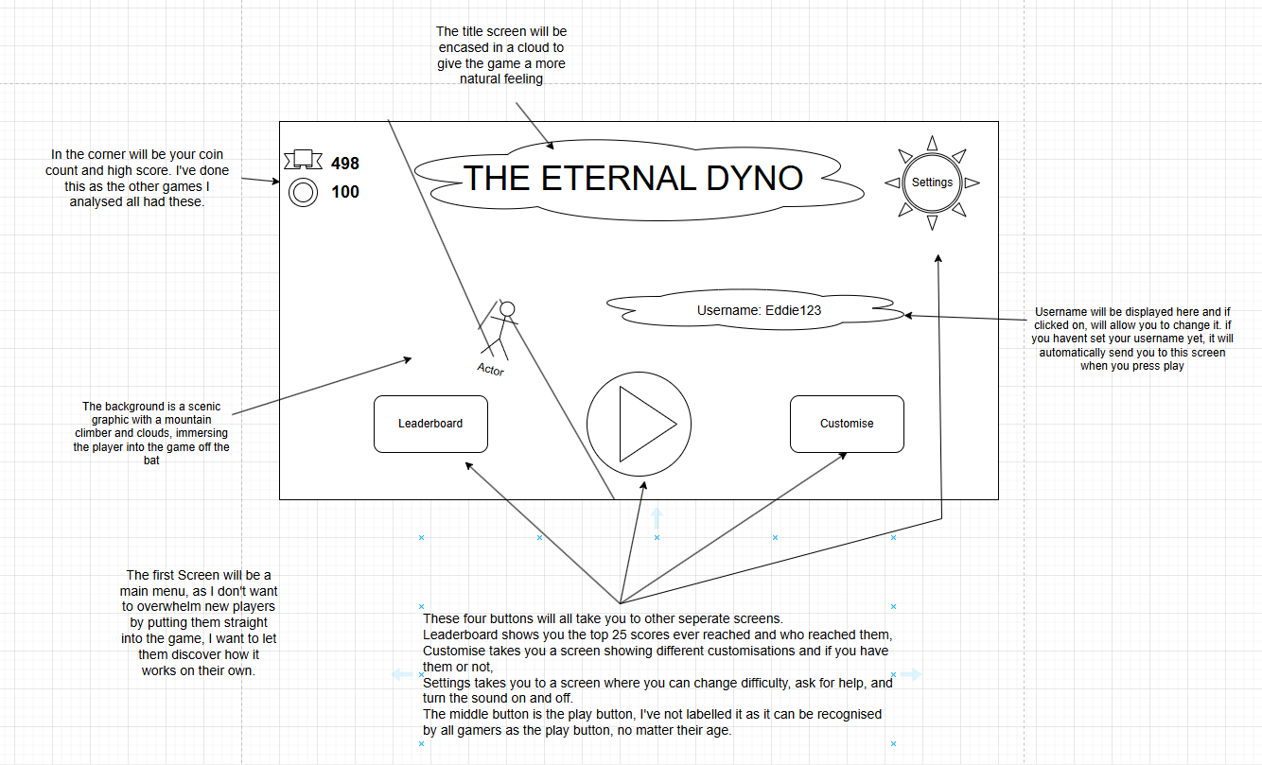

Leaderboard

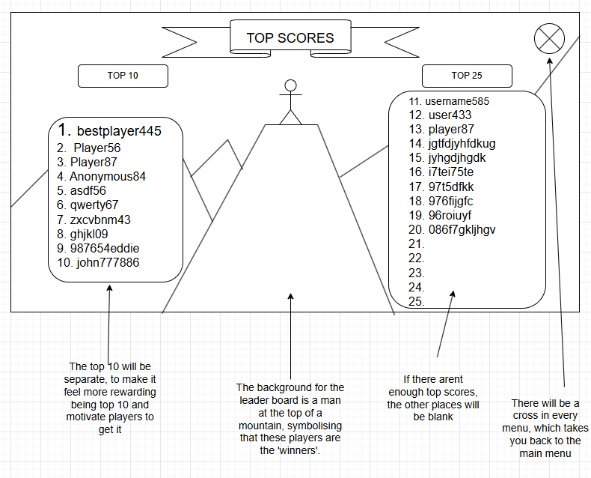

Customisation Screen

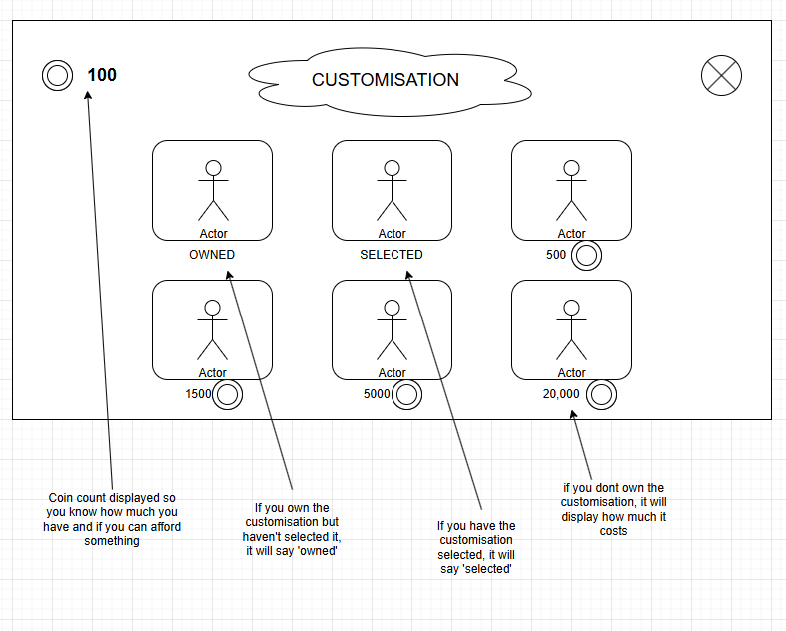

Settings

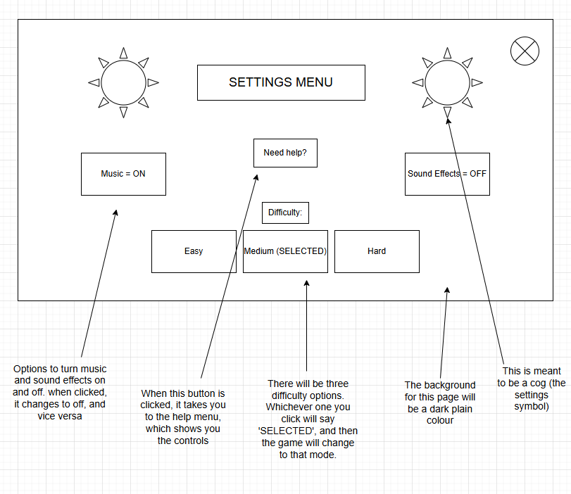

Help Screen

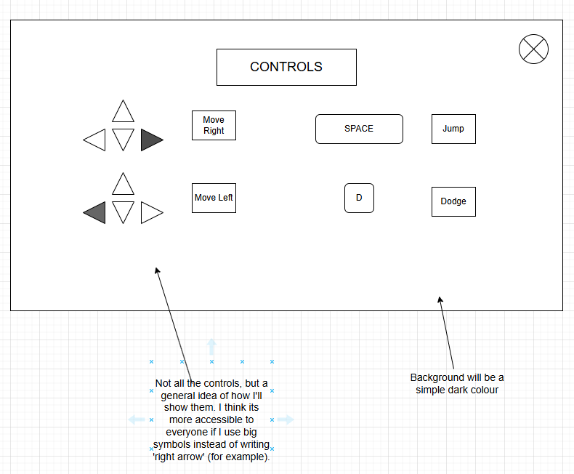

Enter username screen

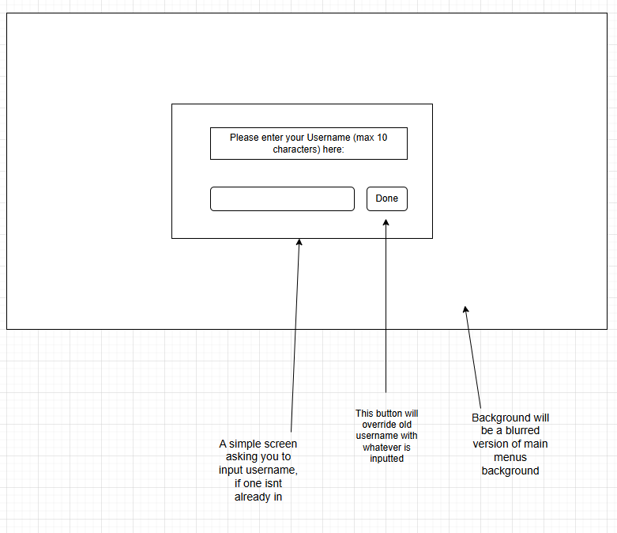

Main Game

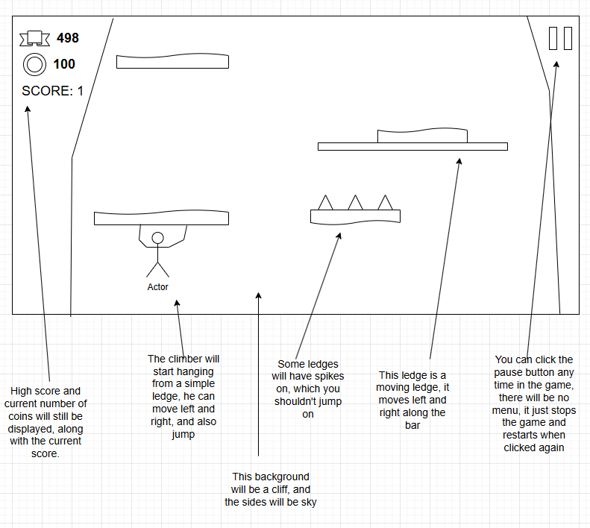

Fall Screen

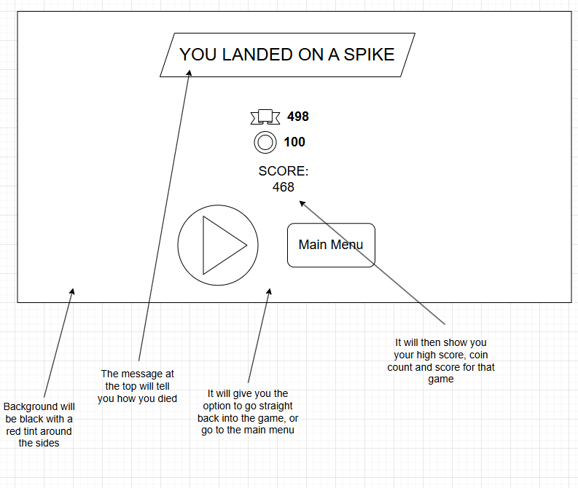

Stages of Development and Test Plans

1: Main Menu

Firstly, I’ll make the game window and main menu. This will include all buttons needed for the main menu, and when clicked will all take you to separate screens (which I’ll work on later). This gives my game a starting point which I can build upon, and I’m doing this first as all features of my game are contained within the main menu.

Features to implement:

1. Window which opens when code is ran
2. First window displays main menu screen
3. Main menu screen has buttons which take you to different blank pages

Test Plan:

|  |  |  |  |  |
| --- | --- | --- | --- | --- |
| Test Number | Description | Test Data | Expected Outcome | SUCCESS/FAIL |
| 1 | Does window open when code is ran? | Run code | Window Opens | SUCCESS |
| 2 | Does the window display the main menu? | Run code, observe window | Displays main menu in window | SUCCESS |
| 3 | Does each button take you to a different blank screen? | Click each button | Each button takes you to a blank screen | SUCCESS |

For proof, refer to the video ‘Stage 1 Tests’.

2:  Basic game  
This is when I’ll make the actual game (adding to the page which you get taken to after pressing the play button on the main menu). I’ll first add solid platforms, the character, and basic movement (left, right, jump). I’m doing this first as the core things the game needs are a character which moves, and platforms. I think making the game with basic functions is the most important thing after the main menu, and after the main menu I’m adding features from most to least important. This is because if I run out of time, I’ll still have the most important features added.

Features to implement:

1. Solid platforms, generated randomly (but enough to make the jump to the platform possible)
2. The character and its different positions (when moving their hands might move left to right or vice versa)
3. Character movement along the platforms (adding key binds for left and right)
4. Jump key bind, and gravity to make the character go up and fall down
5. Making the character connect to the platform with their hands, not feet

3: Improving the game

This is when I’ll add the background, and make it show the players height in game, I’ll also make different platforms (moving, crumbling, spikes) and make it so that the screen moves with the character as it goes up. I’m doing this now as character movement and a basic platform (which I will have already made at this point) will really help in this stage as I can modify the code for the platform which I have already used, and character needs to move to make the screen move and change the height.

Features to implement:

1. A scenic background
2. Screen that locks on to character and follows it as it moves up
3. Height that changes based on how high the character is
4. Different platforms with different features. One with spikes, one moves left to right, one stops being solid after 1 second.

4: Death and fall screen

In this stage I will add the end of the game (falling off screen or hitting a spike), and the fall screen showing how you died and the option to replay or go to main menu  
This is the final stage in making my game fully functional. I’m doing it last because I needed to add the basic ways to end the game in the previous stage first.

Features to implement:

1. When player touches the bottom of the screen, or a spike, it takes you to a screen.
2. Get the score from the game and whether spikes or the bottom of screen was touched, and display messages based on both.
3. Add the play button and the main menu button (play button can use the same function as the play button in the main menu)

5: Boulders

Now I’ll add falling boulders that the player has to dodge (if it hits the player, they fall off). I’ll also add the dodge control. I’m adding this here to increase challenge and the fun of the game now that it fully works.

Features to implement:

1. A solid boulder that moves down the screen at random times in the game, if it touches the player they fall
2. I’ll need to add this as a way to die in the fall screen code (so it can display the death message)

6: Save data

This is where I’ll make the game save the players username, high score, and then add it to a leaderboard showing the top 25 scores and the username of the player who got each one. This will come after the game works, and the boulders are added because it is an extra feature – likes the boulders – but it will take more time to do so adding boulders first means it’s more likely that I can get more features.

Features to implement:

1. Username page which you are taken to when play is pressed (only if you haven’t put a username in already)
2. Option to change username in main menu
3. Saves usernames and high scores is a separate file, meaning when game is closed it still has that data
4. Orders the data in the separate file and records the top 25 scores reached on a leaderboard.

7: Extra features

Character customisation, coins, difficulty levels, sound effects.  
Left until last because they are optional and only if time allows.

Features to implement:

1. Settings menu option in main menu, takes you to a screen which shows difficulty and sound options
2. Different difficulty modes (if difficulty = easy then it will generate more platforms, and the moving platforms will move slower)
3. Coins on platforms, when touched they disappear and 1 is added to the coin count
4. Customise option in the main menu where when a customisation is clicked, it checks if you have enough coins to get it and if you do, you have unlocked that customisation. (this will take a lot of time and isn’t too important so I’m focusing on this last)

Structure Diagram (zoom in to view)

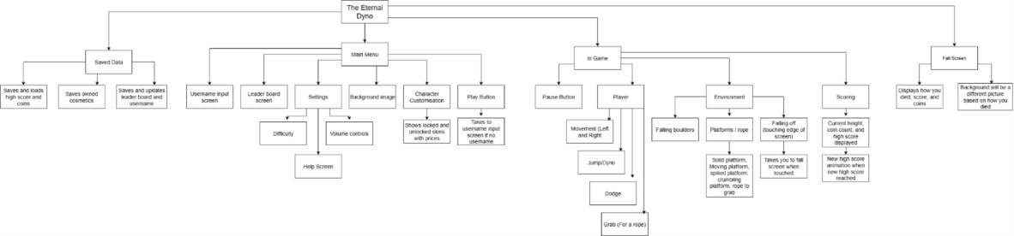Justification:

I chose to split my structure diagram into Saved Data, Main Menu, In Game and Fall Screen.

I did this because the two main screens shown will be the main menu and the actual game, and most other screens fall inside main menu (like settings and leader board). Saved data is its own separate thing so I needed to include that too, then the fall screen isn’t connected to any of the other screens, so I added that.

I then broke each of these four sections into smaller parts as it makes them easier to understand, and less complex meaning I know exactly what to do for each of the sections.

I split the Saved data into saving high score and coins, saving owned cosmetics, and then saving and updating the players username. I grouped high score and coins together as they are always shown together. Owned cosmetics are separate as these will only be shown in the cosmetics menu. The same goes with username, it will only be shown in the main menu and the leaderboard screen.

I split the main menu into each button that will be on it, plus the background. I did this because those are all the features that the main menu needs, and doing this makes it easy for me to know which features to put in the main menu.

For the game, I split it into three core parts, and then the pause button as a miscellaneous part. The three core parts are player, environment and scoring. I did this because each element is its own separate set of features which are vital to the game. Splitting it into these makes it a lot simpler to see what I have to do when coding the game.

For the fall screen, I split it into two parts. These parts are the things displayed, and the background. I listed all the things to display so that when I’m coding this screen, I can refer to my structure diagram to see if I’ve included the right things and remember to add an appropriate background.

After I did this, I split some subgroups into smaller groups. This was because if the subgroup was too big of a task (like settings for example), I had a way of breaking it down and viewing it as separate tasks to make it less overwhelming for me, and give me clear steps on what to include.

Iterative Development

To do for each stage:

DESIGN - pseudocode for that stage, data dictionary, data structures/arrays (if needed), class diagrams

Code and show the key, interesting parts

Document testing, errors, fixing and changes

Do a review at the end of the stage

Stage 1:

Pseudocode:

Data Dictionary:

Background – JPanel is a background

Title – Will show the title over the background image

playbutton – JButton that takes you to the game when clicked

settingsbutton – JButton that takes you to settings when clicked

lbbutton – JButton that takes you to the leaderboard when clicked

customisebutton – JButton that takes you to the customise screen when clicked

usernamebutton – JButton that takes you to the username input screen when clicked

Class Diagram:

|  |
| --- |
| MainMenu |
| Background  Title  playbutton  settingsbutton  lbbutton  customisebutton  usernamebutton |
|  |

Coding:

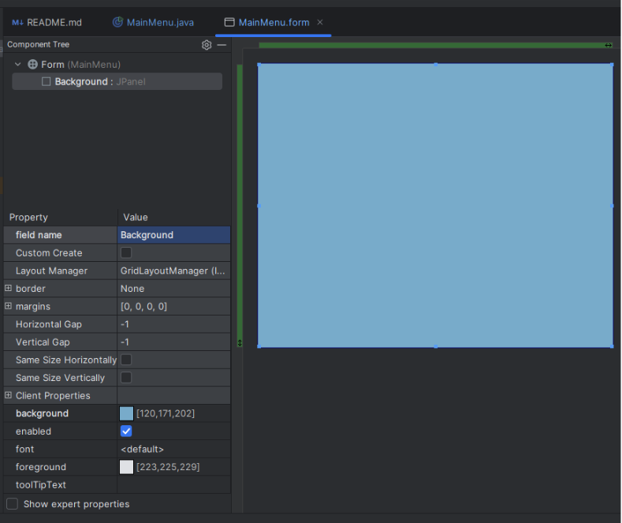

Firstly, I created the GUI form and named it MainMenu – an appropriate name to make things easier in the future. I then created a JPanel filling the whole screen which I gave a colour and then named ‘Background’ as this is my temporary background (I plan on making an actual picture for it soon).

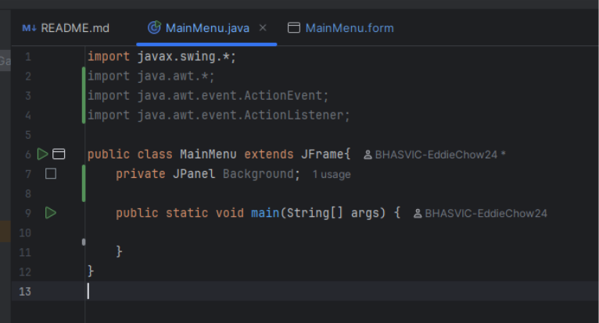

I went onto the java class, and made sure it inherited all the properties from JFrame by writing ‘extends JFrame’ on line 5. I also imported some useful java swing libraries which I got from the Java Swing tutorial I watched [1]. Then I added the main method so that I could run the code and check for errors in the future.

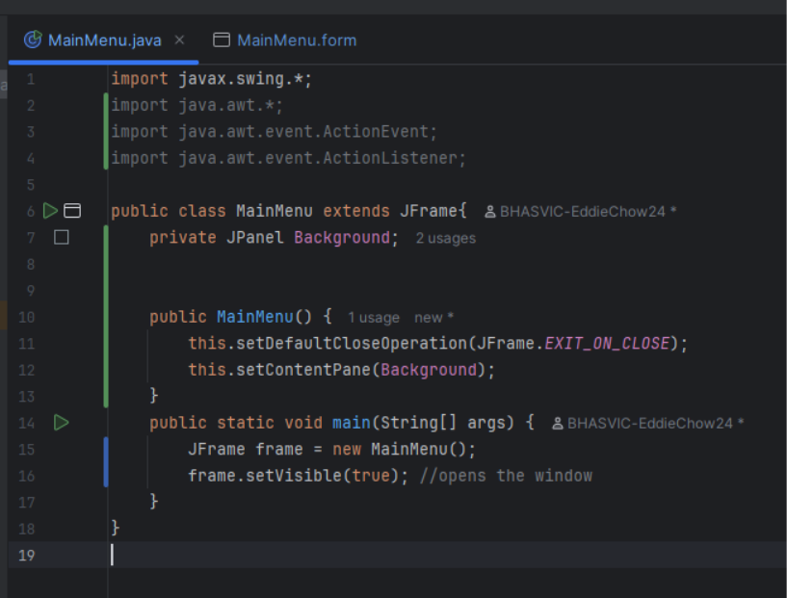

I then referred back to the same tutorial video [2] and added the exit on close function so that the window would close when the x button is clicked, and then I added the content pane as the background, meaning the background is the main content of the window. Then I created a window and called it MainMenu and set the window to be visible (lines 16 and 17). I then ran the code and the window opened successfully.

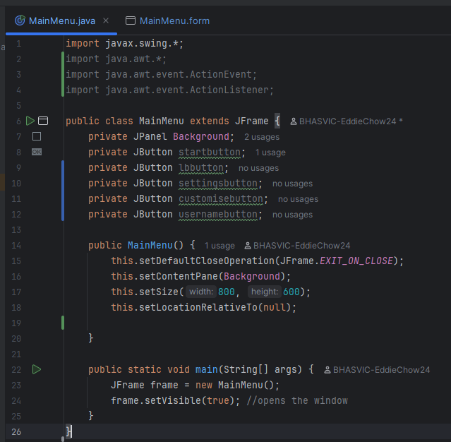

Once I knew that the window opens and displays the background, I added all the other elements (all buttons) that would be in the main menu. I did this so that I know what I have to add in the future. I also used the ‘set size’ and ‘set location relative to’ functions to make the window larger, and set its location to the middle of the screen, as this is how games usually open on a computer.

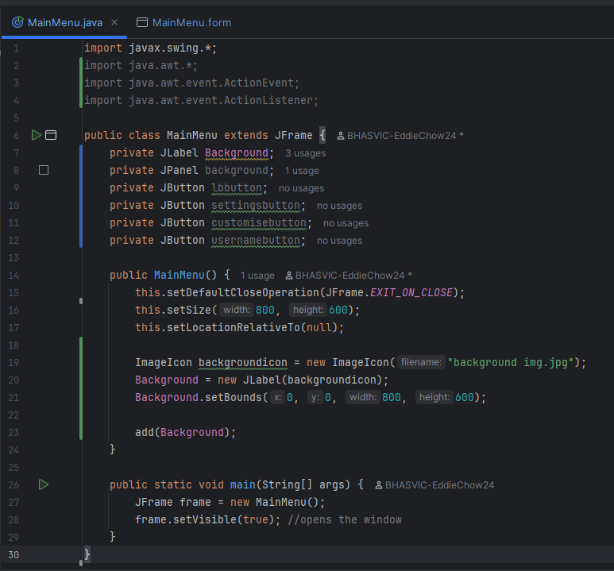

I then searched up the best way to set my background as a file (containing an image), and codingtechroom [3] had the answer, which was to use a JLabel instead of a panel, as then you can easily add an icon to it, directing it to a file. I added Background as a label (I kept the panel as I couldn't remove it in the form section) and then named my image icon ’backgroundicon’ so that I wouldn't get it mixed up with ’background’. After that I put in the filename of my background image, then added it to the JLabel and set its size (the same size as the window). I chose to use a JLabel instead of a JPanel for my background as even though you get more control over the panel, the Label is easier to code and I don‘t need that control (all I need to do is add an image to it). Finally, I added the Label to the JFrame using the add() function.

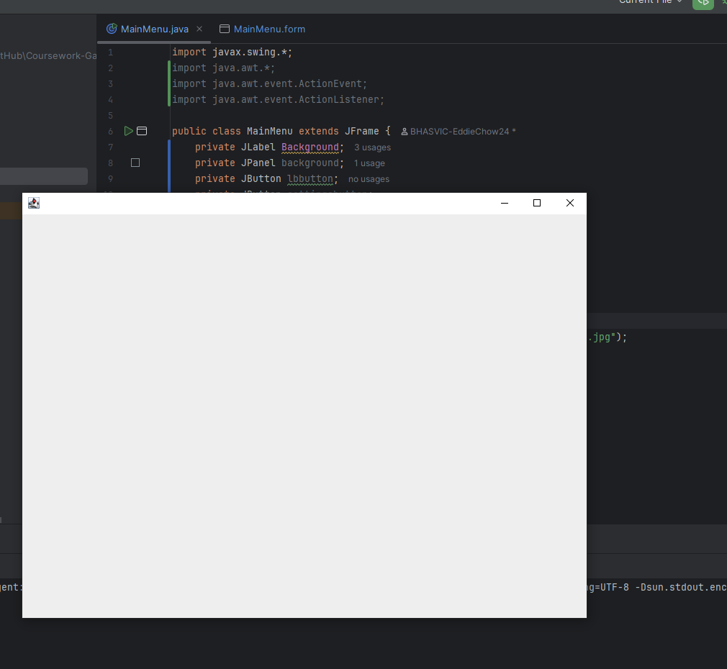

I then ran my code and saw that the image I wanted didn't actually show up when the window opened.

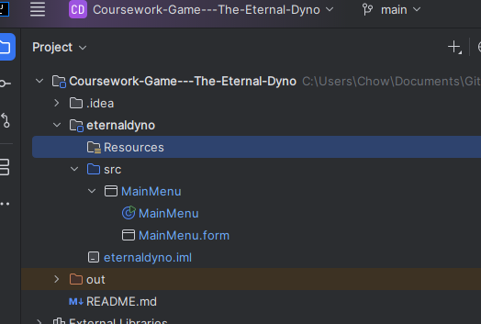

I realised I was trying to get the image I wanted straight from files, and you're supposed to have it stored in your program, so I added a directory and named it resources, then marked it as a resources route.

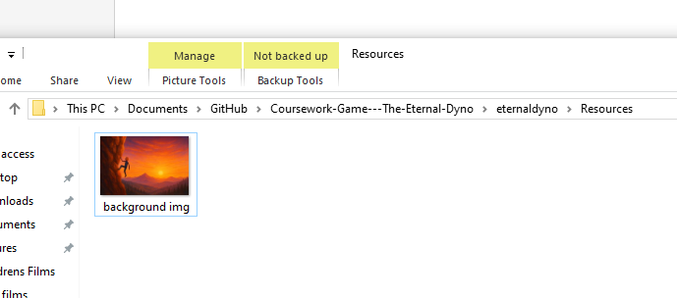

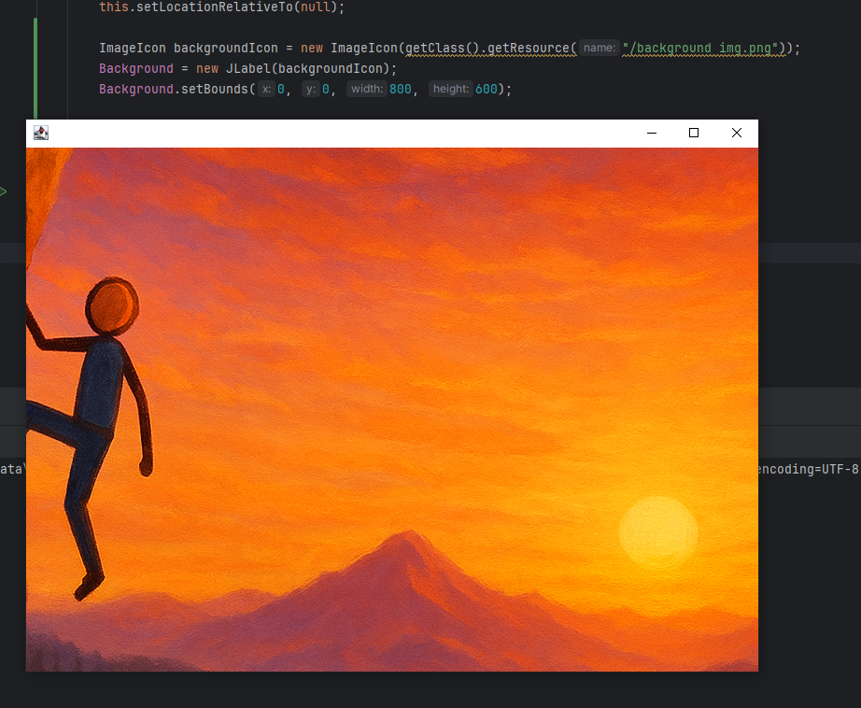

I added the file to the resources folder, then used the getclass and getresources functions so that my code would access it. Finally, I ran the code and it successfully showed up on the window, however it wasn't the whole image shown.

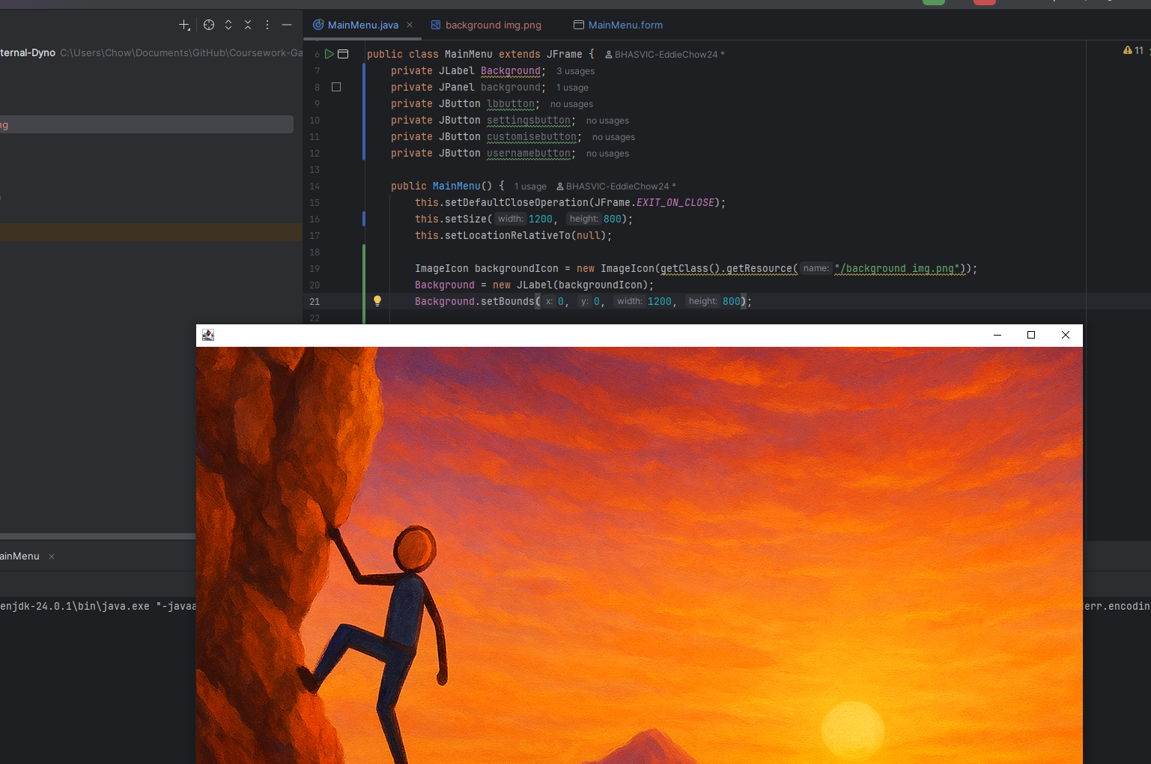I changed the size of the main menu and the bounds of the image, and then after running, the whole image showed up on the window. At this point, I realised that the GUI form wasn’t doing anything, so I deleted it to make things less complicated.

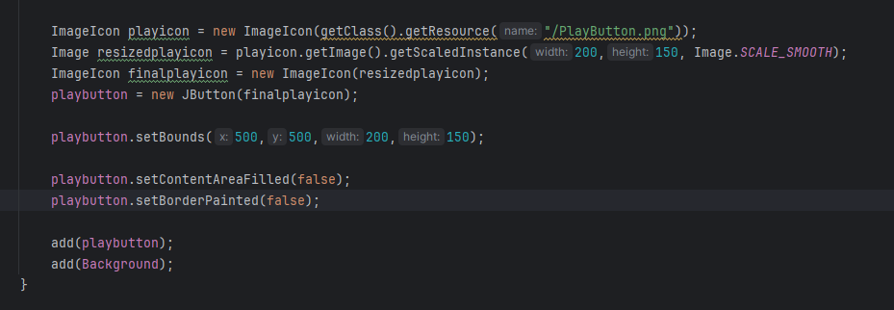

I then needed to add the play button. To do this I Created an Image Icon of A picture of a play button with no background. I wanted to make sure it had no background so you can see behind it, making the main menu feel more smooth and less blocky. I directed the image icon to the corresponding file, and then resized it as otherwise it would fill up the whole screen, and I need space for more buttons. After resizing It was in the format of an image but in needed it to be an image icon, so I made a new icon and set it to the resized image. Then I set the location for the button. Finally, I get rid of the background with the ‘setcontentareafilled’ function, got rid of the border too then added it to the main menu.

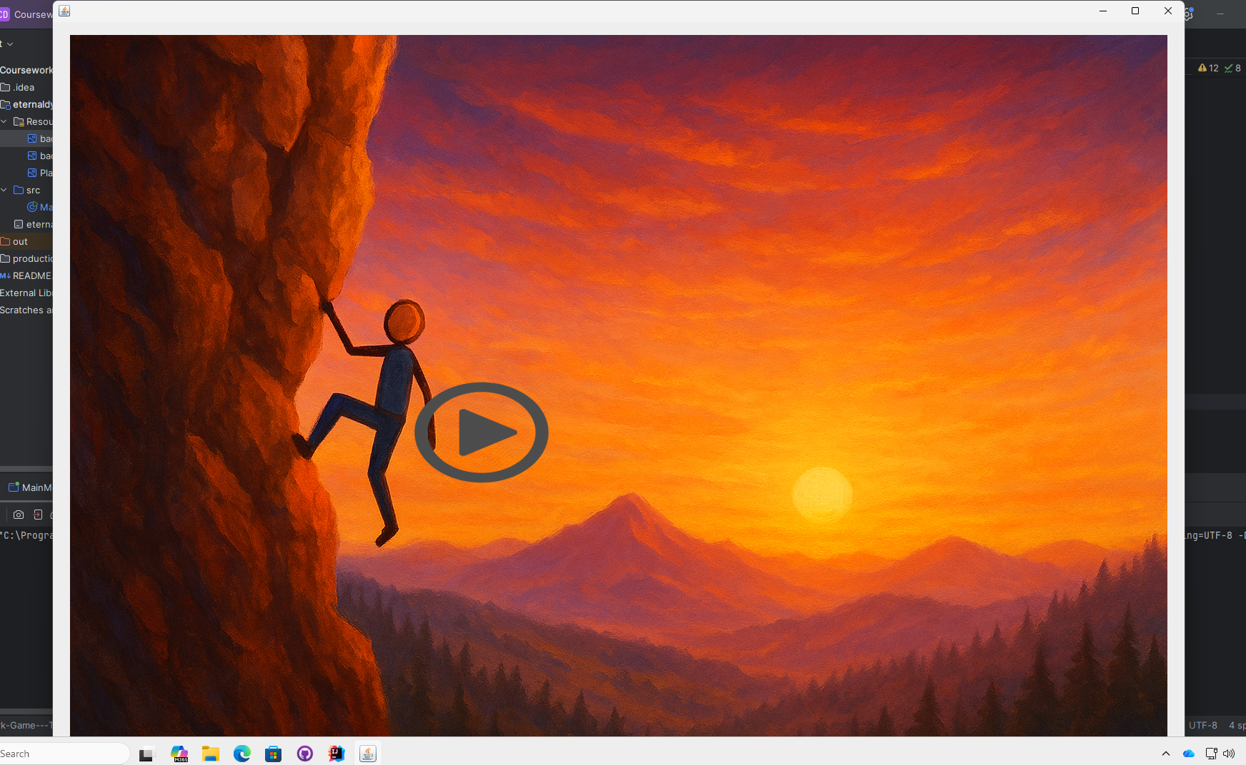

When I ran the code after modifying the size of the window, The play button was not centred to the window.

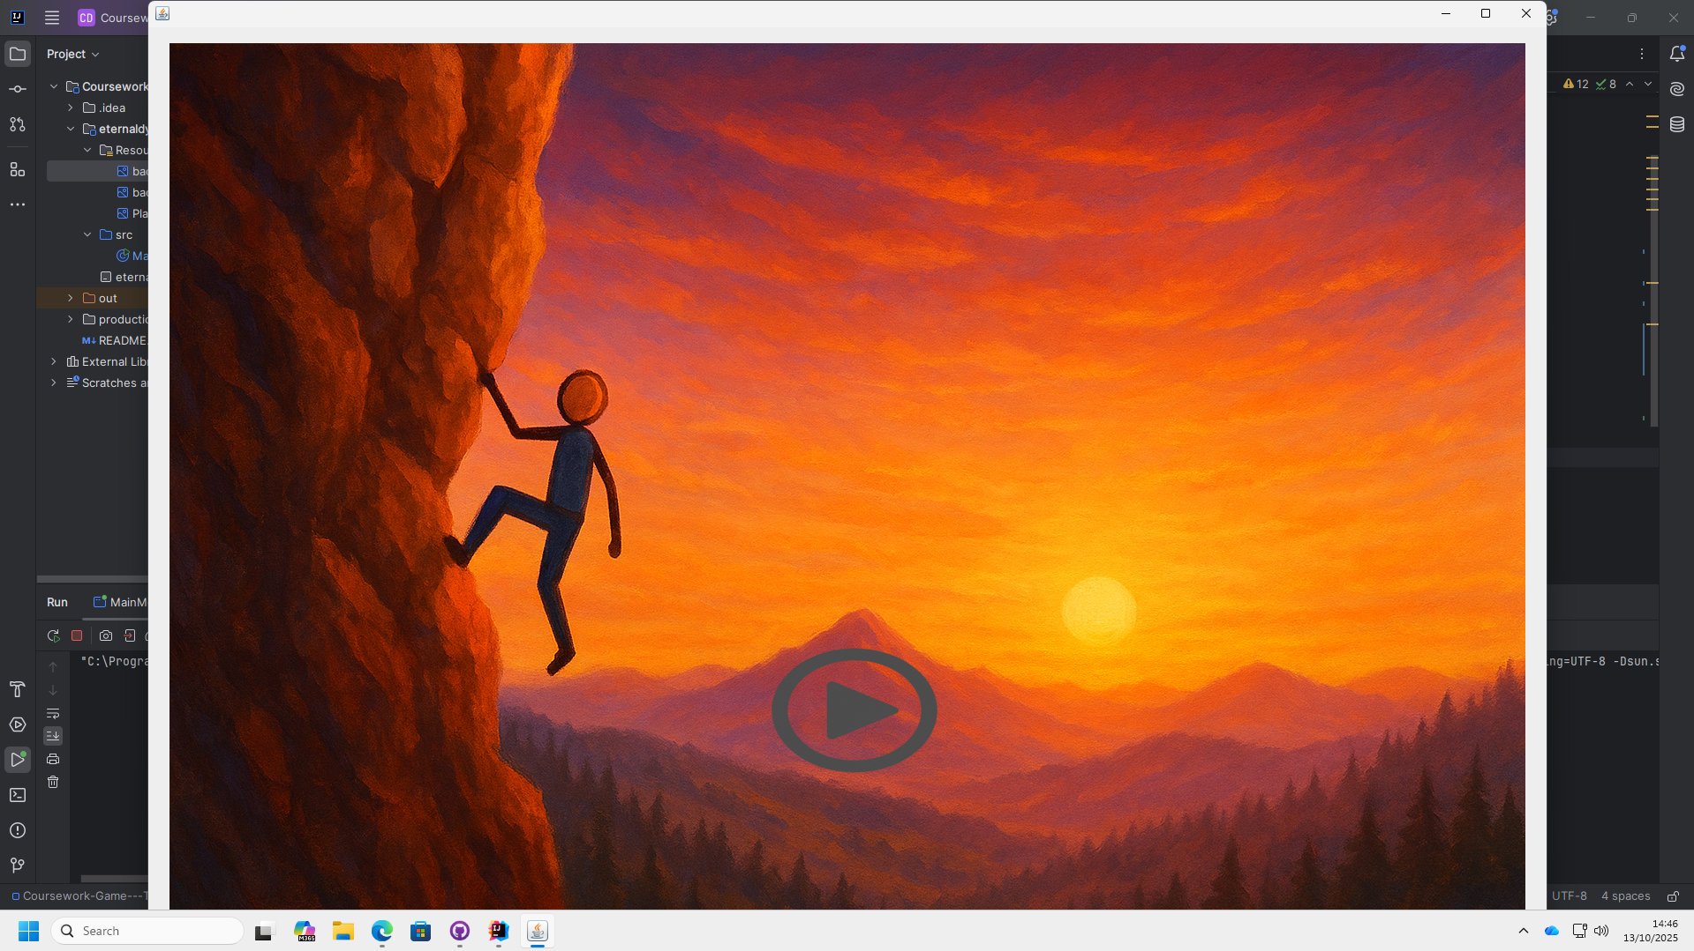

After trial and error, I found the right location to put my button (this was x = 700, y = 700)

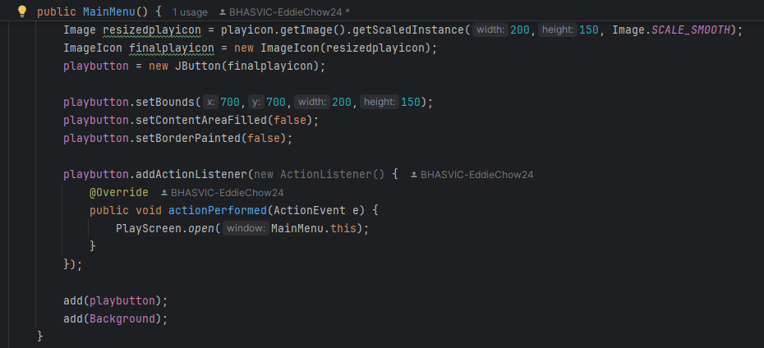

I then moved onto getting the button to take you to a blank screen. I devised that the best way to do this was by replacing the current window with the screen, instead of opening a new window every time (as that would be inefficient and hard to navigate). I created an action listener for the play button and then created a new class for it. I chose to add this code in a different class as is separates the code into different sections, making it easier for me to understand and know where to add my code in the future.

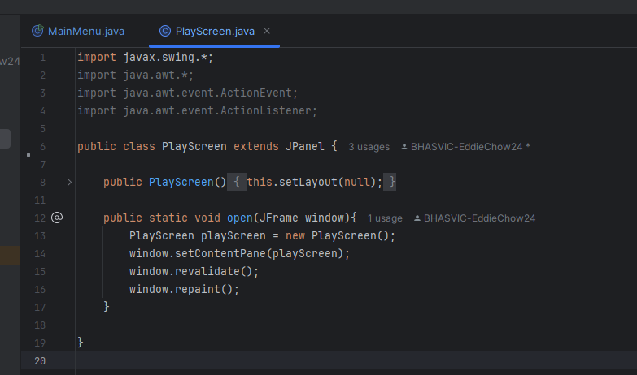

This is my PlayScreen class, it has a public ‘open’ function (so that main menu can call it). I figured out that the best way to make it open in the same window was to take in the current window as a parameter and set the windows content to what I want it to be. This is good because it means I can reuse the open function in the future when opening different screens.

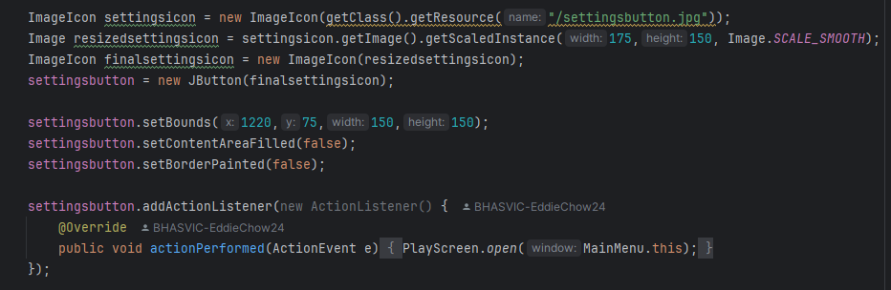

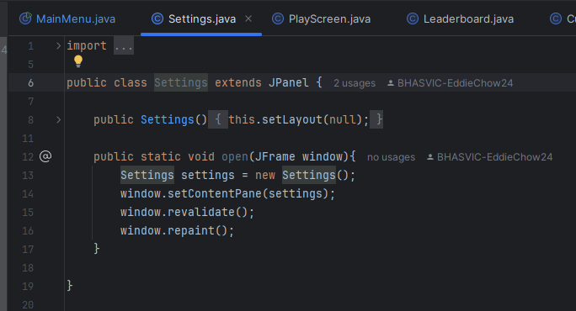

Now that I know what to do in order to make a button open a new window in a new class, I repeated this for all of my buttons; leaderboard, settings, customise and username input, making a separate class for each one, with a function called open, and the elements and action listener for each one in the main menu class (which is where the main function is). I did this because having them all in separate classes makes it good for the future when I want to add different functions to each one.

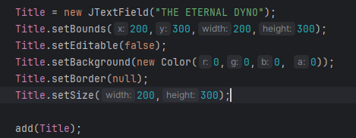

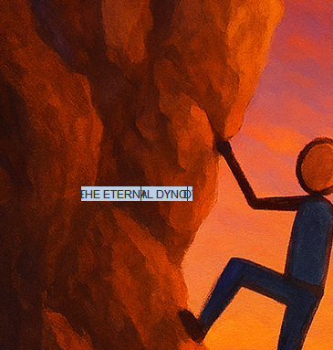

I added my title as a text field, set its bounds and size, made sure you couldn't edit it, then made it fully transparent. When I ran the game, it appeared in the wrong place, with the wrong colour and I was able to highlight it, which I didn't want.

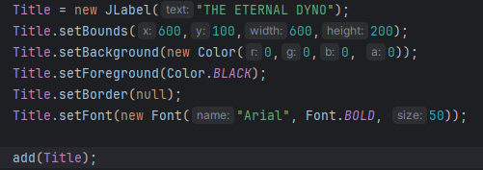

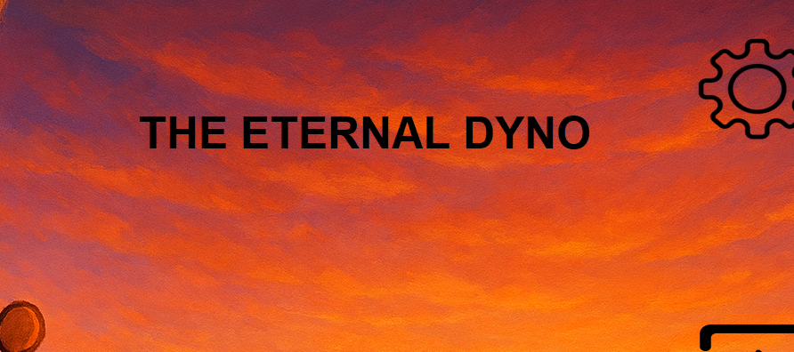

I then realised that if it was a JLabel, it would automatically not let you edit or highlight it, which fixes one problem and also makes the code simpler. After than I set the colour to black and set the font to Arial, so I could chang the font size to make it bigger. Now it looks good, but I don't like the font.

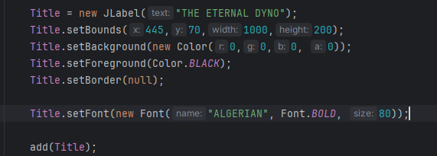



I then went on to Microsoft word and looked at the fonts it offered. I found ‘Algerian’ which I liked. I set the font to Algerian, changed the size, and then changed the bounds to centre it. I like this font because it goes with the background well and it’s pleasing to look at, which I think my players will really like.

1. [How to Build a Swing GUI with IntelliJ IDEA](https://www.youtube.com/watch?v=-SmNpKskfJc&list=PLdo0UJutH1YYsKWLsTVDo-wgGmikHeK9n)
2. [How to Build a Swing GUI with IntelliJ IDEA](https://www.youtube.com/watch?v=-SmNpKskfJc&list=PLdo0UJutH1YYsKWLsTVDo-wgGmikHeK9n)
3. [How to Add an Image as a Background in a Java Layout? - CodingTechRoom](https://codingtechroom.com/question/-java-add-image-background-layout)